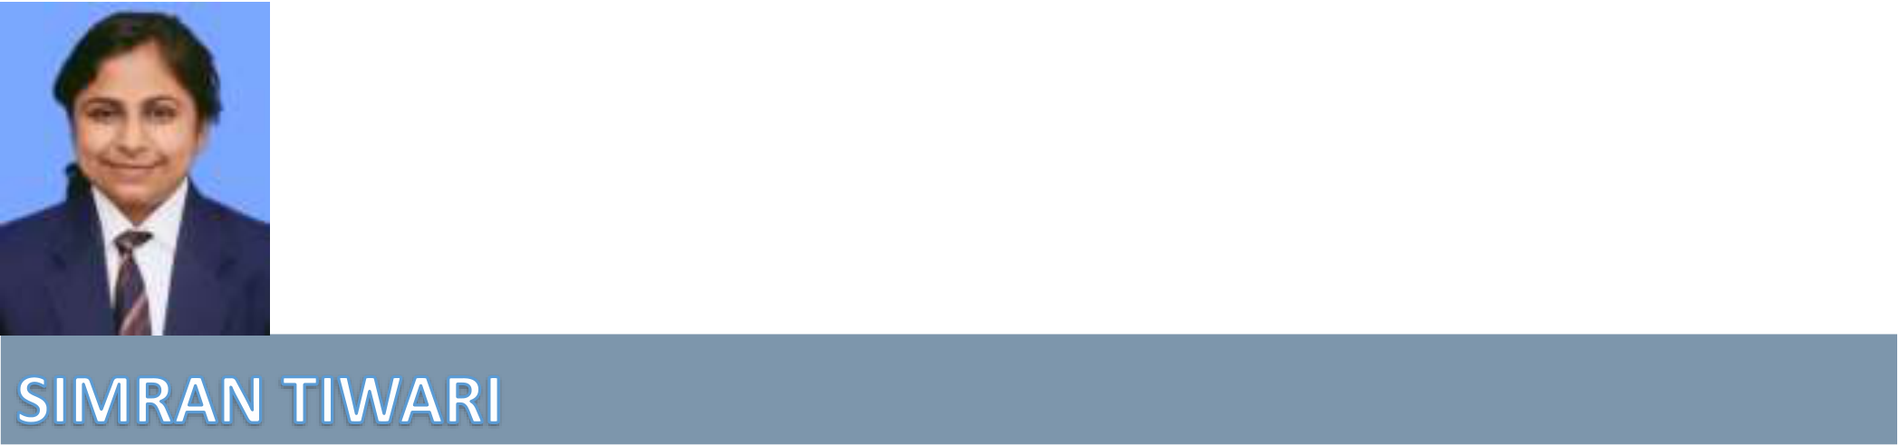

Poni road   
Shuklaganj, Unnao   
209861 U.P. India   
+91-8707868330   
simrantiwari127@gmail.com

|  |  |
| --- | --- |
| OBJECTIVE | To seek better growth opportunities and challenging environment where I can make best use of my talent. |



|  |  |  |  |
| --- | --- | --- | --- |
| EDUCATIONAL | • | M.C.A. from Dr. A.P.J. Abdul Kalam Technical University Lucknow | |
| (Pursuing)**(6.70 CGPA)** | |
| QUALIFICATION | • |
| B.C.A. 2017-2020 Chhatrapati Shahu Ji Maharaj University Kanpur **(59.62%)** | |
| • |
| Intermediate U.P. State Board 2017 | **(74.50%)** |
| • |
| High School UP Board 2015 | **(79.5%)** |



|  |  |  |
| --- | --- | --- |
| TECHNICAL | • | 3 Year Graduation from Computer Science Domain with Strong Programming Background. |
| QUALIFICTAION | • | Pursuing for 2 year Post Graduation in Computer Science domain with major in programming and software development field. |
| • | Understanding of Basics of Computer Programming & IDE’s. |



|  |  |  |
| --- | --- | --- |
| ADDITIONAL | • | Microsoft Office (Excel, Access, Word, Publisher) |
| • |
| DBMS |
| • | Graphics Designing |
| TECHNICAL |
| • | WordPress |
| SKILLS |
| • |
| HTML |
| • | CSS |
| • | Basic of Ethical Hacking With Certificate of 2018 |
| • |
| Attending 42 Days Training program on Python from Axpino Technologies. (*With Certification*) |



\

|  |  |  |
| --- | --- | --- |
| PROGRAMMING | • | C |
| • |
| C++ |
| LANGUAGES | • | Python (Core) |
| • |
| SQL |

|  |  |  |
| --- | --- | --- |
| PROJECT 1 | **Loan prediction using ml currently working** Core Language **Python** | |
|  | • | Interest in learning new things coming in my field. |

|  |  |  |
| --- | --- | --- |
| HOBBIES | • | Article Readings on latest and Upcoming Technologies and Market Changes |
| • |
| Coding |
| STRENGTH | • | Willingness to learn, Trustworthy and Responsible |
| • | Leadership and Management, self-motivated Disciplined |

|  |  |  |  |
| --- | --- | --- | --- |
|  | • | Implementing Innovative Ideas | |
|  | **Name** | | Simran Tiwari |
|  | **Father’s Name** | | Mr Ashok Kumar tiwari |
| PERSONAL DETAILS | **Date Of Birth** | | 08-Mar-2000 |
|  | **Nationality** | | Indian |
|  | **Gender** | | Female |
|  | **Marital Status** | | Unmarried |
|  | **Language Known** | | English & Hindi |
|  | **Permanent Address** | | Poni road Shuklaganj Unnao 209861 UP India |
|  | **Home Contact No.** | | +91-9026527002 |

**Declaration**

I hereby, declare that all the information give here are true the best of my knowledge and belief

**DATE:- 19-June-2022**

**PLACE: Kanpur**

(Simran Tiwari)